4.
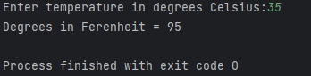
5.
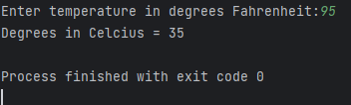
6./
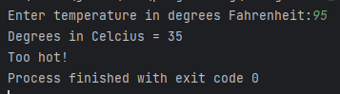
7.
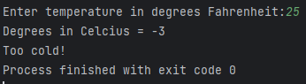

/*
* Jakub Olszewski
* Student ID: 23710521
* Date: 26.09.2023
*/
#include <stdio.h>
int convertCelciusToFahrenheit(int degC){
int degF = 0;
degF = 32 + (degC*9)/5; // Converts Celcuis to Fahrenheit using given formula
return degF; //returns degrees in Fahrentheit
}
int convertFahrenheitToCelcius(int degF){
int degC = 0;
degC = (degF-32)*5/9; // Converts Fahrenheit to Celcuis using given formula
return degC; //returns degrees in Celcius
}
int main() {
int inputDegree = 0;
printf("Enter temperature in degrees Fahrenheit:");
scanf_s("%d",&inputDegree); //Assigning integer given by user into varible
int degC = convertFahrenheitToCelcius(inputDegree); // executes converting fuvtion
printf("Degrees in Celcius = %d \n", degC); // Prints a result
if (degC>32){ // Checking specified condition
printf("Too hot!");
}
if (degC<0){// Checking specified condition
printf("Too cold!");
}
return 0;
}

